USWCA OPEN 5 Year and Under
October 27 & 28
Rochester Curling Club

BBQ and Black Jack
 | & | 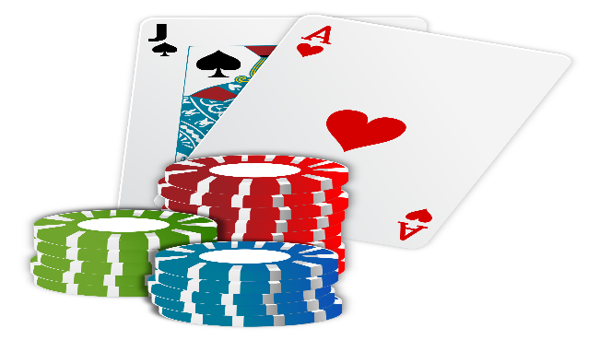

3 Game Guarantee
Everyone Plays Both Days
16 Team Limit

$220.00 per Team
Includes Continental Breakfast Saturday and Sunday
Lunch Saturday, BBQ Dinner Saturday followed by a game night.
Brunch will be available Sunday during and after the finals.

Eligibility: Any curler with five (5) years or less of total curling experience is eligible to participate.
Each skip must submit an Eligibility Form when the rink is registered. Eligibility Forms must be signed
by a club officer to verify that each member of the team has in fact curled five years or less.
Composite team registrations are acceptable. Eligibility Forms are required for all participants.

Registration Form, Eligibility Forms, Waivers and Entry Fee
must be received by September 26th.

Holiday Inn Express –will hold a block of rooms for $99.00 per night for the
Rochester Curling Club until September 26th. See information below.

Online Registration at RochesterCurling.org  will begin on September 4th. Registrations will not be considered complete without paperwork for all team members and payment.  You will receive a confirmation email.  Contact for questions: Carol Wood at carwood47@yahoo.com | Hotel Accommodations:  Holiday Inn Express  717 East Henrietta Road  Rochester, NY 14623  585-272-7800  Reservation Group Code: RCC

